**What is the purpose of the core module in AEM?**

The **Core Module** in AEM is the **backend logic layer** where all business functionality is written in **Java**. It follows the **OSGi (Open Service Gateway Initiative)** framework, which allows the development of modular and reusable services.

It contains the core business logic like:

* Sling Models
* OSGi Services
* Servlets
* Utility Classes
* Constants
* Custom Business Logic

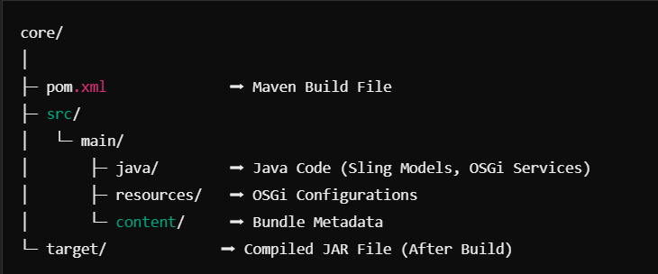

**What kind of files and code can be found in the core folder?**

The **Core Folder** in an **AEM Project** contains all the **backend business logic** and **Java code** required to support frontend components. This module follows the **OSGi framework** to create reusable and modular services.

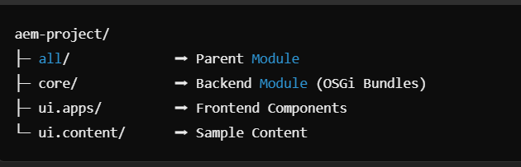

"Core Module acts as the brain of the AEM project where all backend business logic, services, and reusable components are written using OSGi."

**Explain the role of ui.apps in AEM projects.**

The ui.apps module is responsible for:

* Defining the AEM components (HTML, CSS, JS)
* Configuring dialog properties
* Creating Client Libraries for styling and scripts
* Storing OSGi configurations
* Project-specific templates and pages
* Defining Editable Templates and Policies

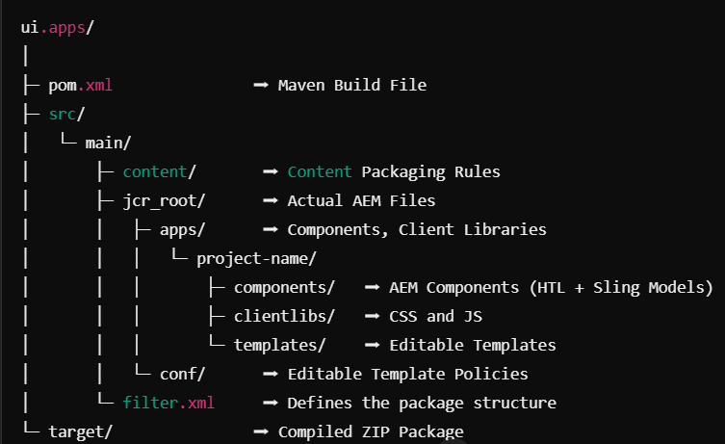

**How are components structured in the ui.apps folder?**

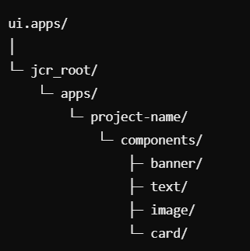

component-name/ │

├─ component.html ➡ HTL Template

├─ _cq_dialog/.content.xml ➡ Dialog Configuration

├─ _cq_editConfig.xml ➡ Edit Bar Settings

└─ clientlibs/ ➡ CSS + JS (Optional)

**Hello World Component:**

* **Where is the Hello World component located in both core and ui.apps?**

In an **AEM Project**, the **Hello World Component** is typically created to demonstrate the basic structure of an AEM component by connecting **backend Java logic** with **frontend templates**.

|  |  |  |
| --- | --- | --- |
| **Core** | Backend Business Logic | com.projectname.core.models.HelloWorldModel.java |

|  |  |  |
| --- | --- | --- |
| **ui.apps** | Frontend Component + Dialog | /apps/projectname/components/helloworld |

**Explain the Java class (in core) for the Hello World component.**

Location:  
 /core/src/main/java/com/projectname/core/models/HelloWorldModel.java

When the component is dragged onto a page, the dialog allows authors to input the **message**.

AEM automatically injects the dialog value into the **message** variable using **@Inject**.

The getMessage() method exposes this value to the HTL file for rendering.

* **How does the HTL script work in ui.apps for Hello World?**

The HTL (HTML Template Language) script in the ui.apps module is used to display content dynamically on the webpage.

**HTL Attribute Purpose**

${model.message} Calls the **getMessage()** method from the model to

display the **message** value dynamically.

data-sly-use Links the **HelloWorldModel** Java class to the HTL template.

<div> Displays the final message content on the webpage.

**How are properties and dialogs defined for this component?**

The dialog appears when authors edit the component.

The author enters a message in the Text Field.

• The value is stored as message property.

• The Sling Model fetches the property and renders it through HTL.

**What are the different types of AEM modules (core, ui.apps, ui.content, etc.)?**

AEM modules organize the project structure. The Core Module handles backend logic with Sling Models. The ui.apps Module defines components, dialogs, and HTL scripts. The ui.content Module stores initial content. The ui.config Module manages OSGi configurations. The ui.tests Module contains test cases. The Parent Module manages project dependencies using Maven, making the project scalable and maintainable.

**How does Maven build these modules?**

Maven builds AEM modules using the POM file, which defines dependencies and configurations. The Parent Module controls submodules like core, ui.apps, and ui.content. Running mvn clean install compiles code, packages modules, and deploys them to AEM using Maven plugins, ensuring consistent and automated builds.

**Explain the build lifecycle of Maven in the context of AEM.**

Maven's build lifecycle in AEM follows sequential phases to compile, package, and deploy code. It starts with the clean phase, which deletes previous build files. The validate phase checks project structure, followed by compile to compile Java code.

The test phase runs unit tests, and package creates JAR or ZIP files. The install phase stores the package in the local repository, while deploy uploads the package to the AEM instance using Maven plugins. This lifecycle ensures smooth, automated, and consistent builds for AEM projects.

**How are dependencies managed in pom.xml?**

In AEM, dependencies are managed in the pom.xml file using the Maven <dependency> tag. Each dependency specifies the groupId, artifactId, and version to identify external libraries or APIs. Maven downloads these dependencies from remote repositories and stores them locally. The <dependencies> section lists all required libraries, while <dependencyManagement> defines common versions across modules. This ensures consistent dependency versions, automatic downloading, and easy project management.

**Why is Maven used instead of other build tools?**

Maven is used in AEM because it provides standardized project structure, dependency management, and automated builds. It simplifies managing complex projects with multiple modules through its POM-based configuration. Maven automatically downloads dependencies, ensures version consistency, and integrates easily with AEM plugins for packaging and deployment. Its lifecycle management, scalability, and wide community support make it more suitable for AEM than other build tools.

**What advantages does Maven offer for AEM development?**

Maven offers several advantages for AEM development, such as automated dependency management, ensuring consistent library versions across modules. It provides a standard project structure, making the code easier to maintain. Maven's build lifecycle automates compiling, testing, packaging, and deploying code. It supports plugins like content-package-maven-plugin for seamless AEM package creation and deployment. Additionally, Maven's modular architecture improves scalability, while its community support makes troubleshooting easier.

**How does Maven help in managing dependencies and plugins in AEM projects?**

Maven manages dependencies in AEM projects using the pom.xml file, where required libraries are declared under the <dependencies> tag. It automatically downloads and caches these libraries from remote repositories. The <dependencyManagement> section ensures consistent versions across modules. Maven also uses plugins like content-package-maven-plugin and maven-sling-plugin to automate tasks such as code compilation, unit testing, and AEM package deployment, making the build process more efficient and consistent.

**What does mvn clean install do in an AEM project?**

The mvn clean install command in an AEM project performs two tasks:

1. clean – Deletes previous build files from the target directory.
2. install – Compiles code, runs unit tests, packages the project into JAR or ZIP files, and installs the packages into the local Maven repository.

This command ensures a fresh build and prepares the project artifacts for deployment.

**How to deploy packages directly to AEM using Maven commands?**

To deploy packages directly to AEM using Maven, use the mvn clean install -PautoInstallPackage command. This command builds the project and automatically installs the generated packages into the AEM instance.

The -PautoInstallPackage profile is defined in pom.xml, specifying the AEM instance URL, credentials, and deployment plugin. For author and publish environments, use -PautoInstallPackagePublish to deploy packages to the publish instance.

**Explain the purpose of different Maven profiles in AEM (autoInstallPackage, autoInstallBundle).**

Maven profiles in AEM are used to build and deploy code to different environments. The autoInstallPackage profile deploys the full content package (code, components, and content) to the author instance. The autoInstallBundle profile only installs the OSGi bundles (core JAR files) without affecting content. These profiles help automate deployments to different AEM instances, making the build process more flexible and environment-specific.

**What is the purpose of dumplibs in AEM?**

The dumplibs tool in AEM is used to list all client libraries (clientlibs) available in the system. It helps developers debug and verify client libraries by showing their dependencies, categories, and paths. The tool is accessed via the URL:  
http://localhost:4502/libs/granite/ui/content/dumplibs.html

It helps identify missing client libraries or dependency conflicts during development, ensuring proper client-side rendering of CSS and JavaScript files.

**How can you view client libraries using dumplibs?**

You can view client libraries using dumplibs in AEM by accessing the URL:  
http://localhost:4502/libs/granite/ui/content/dumplibs.html

Once opened, select the Categories tab to see all available client libraries with their category names. You can also filter libraries, view their dependencies, and check their paths. This tool helps debug and verify if the correct CSS and JavaScript files are loaded in AEM components.

**Explain how client libraries are structured in AEM.**

In AEM, client libraries are structured to manage CSS, JavaScript, and other frontend assets. They are stored under the /apps/projectname/clientlibs folder. Each client library folder contains a cq:ClientLibraryFolder node with properties like categories to define library usage. The folder typically includes:

* css/ – Stores CSS or SCSS files.
* js/ – Contains JavaScript files.
* resources/ – Holds images or fonts.
* clientlib-base.less or clientlib-base.js – Main entry files.
* .content.xml – Defines client library properties.

Client libraries improve code reusability, caching, and dependency management in AEM projects.